**Project: Compucom Tracker**

**Project ID: CSL/13/SW/Web/OS/004**

**Design Document**

**Author: Rajesh Kumar Arora**

**Reviewed By: Manoj Agrawal**

**Revision History**

|  |  |  |  |  |  |
| --- | --- | --- | --- | --- | --- |
| **S.No** | **Ver.** | **Date** | **Author** | **Reviewed by** | **Reason** |
| 1 | Draft | 20/12/2017 | Rajesh Kumar Arora | Manoj Agrawal | New Document |
| 2 | Draft | 20/01/2017 | Rajesh Kumar Arora | Manoj Agrawal | New table schema |
| 3 | 1.0 | 05/02/2014 | Rajesh Kumar Arora | Manoj Agrawal | Improvement |
|  |  |  |  |  |  |
|  |  |  |  |  |  |

**User Management**

1. **gpslocations**

|  |  |  |  |  |  |  |
| --- | --- | --- | --- | --- | --- | --- |
| **Name** | **Datatype** | **Size** | **Nulls?** | Constraints | | **Description** |
| GPSLocationID | int | 10 | No | PK | | Auto |
| lastUpdate | timestamp |  | No |  | |  |
| latitude | decimal | 10, 7 | No | |  |  |
| longitude | decimal | 10, 7 | No | |  |  |
| phoneNumber | Varchar | 50 | No | | Index |  |
| userName | Varchar | 50 | No | | Index |  |
| sessionID | Varchar | 50 | No | | Index |  |
| speed | int | 10 | No | |  |  |
| direction | int | 10 | No | |  |  |
| distance | decimal | 10, 1 | No | |  |  |
| gpsTime | timestamp |  | No | |  |  |
| locationMethod | Varchar | 50 | No | |  |  |
| accuracy | Int | 10 | No | |  |  |
| extraInfo | Varchar | 255 | No | |  |  |
| eventType | Varchar | 50 | No | |  | Time of Creation/updation of the record |

1. **pt_position**

|  |  |  |  |  |  |  |
| --- | --- | --- | --- | --- | --- | --- |
| **Name** | **Datatype** | **Size** | **Nulls?** | Constraints | | **Description** |
| Id | int | 11 | No | PK | | Auto |
| Unit_id | int | 11 | No | Index | |  |
| datetime | datetime |  | No |  | |  |
| datetime_received | datetime |  | No |  | |  |
| lat | double |  | No |  | |  |
| lon | double |  | No |  | |  |
| alt | double |  | No |  | |  |
| deg | double |  | No |  | |  |
| speed_km | double |  | No | |  |  |
| speed_kn | double |  | No | |  |  |
| sattotal | int |  | No | |  |  |
| fixtype | int | 11 | No | |  |  |
| raw_input | tinytext | 11 | No | |  |  |
| hash | char | 32 | No | |  | Time of Creation/updation of the record |

1. **pt_position_unreguser**

|  |  |  |  |  |  |  |
| --- | --- | --- | --- | --- | --- | --- |
| **Name** | **Datatype** | **Size** | **Nulls?** | Constraints | | **Description** |
| id | int | 10 | No | PK | | Auto |
| user_entry | char | 25 | No |  | |  |
| datetime | datetime |  | No | |  |  |
| datetime_received | datetime |  | No | |  |  |
| lat | double |  | No | |  |  |
| lon | double |  | No | |  |  |
| alt | double |  | No | |  |  |
| deg | double |  | No | |  |  |
| speed_km | double |  | No | |  |  |
| speed_kn | double |  | No | |  |  |
| sattotal | Int | 11 | No | |  |  |
| fixtype | Int | 11 | No | |  |  |
| raw_input | tinytext |  | No | |  |  |
| hash | char | 32 | No | |  | Time of Creation/updation of the record |

1. **pt_unit**

|  |  |  |  |  |  |  |
| --- | --- | --- | --- | --- | --- | --- |
| **Name** | **Datatype** | **Size** | **Nulls?** | Constraints | | **Description** |
| id | int | 4 | No | PK | | Auto |
| user_id | int | 4 | No | Index | |  |
| name | tinytext |  | No | |  |  |
| imei | tinytext |  | No | |  |  |
| password | char | 32 | No | |  |  |
| icon | int | 11 | No | |  |  |
| linecol | int | 11 | No | |  | Time of Creation/updation of the record |

1. **pt_user**

|  |  |  |  |  |  |  |
| --- | --- | --- | --- | --- | --- | --- |
| **Name** | **Datatype** | **Size** | **Nulls?** | Constraints | | **Description** |
| id | int | 11 | No | PK | | Auto |
| name | tinytext |  | No |  | |  |
| username | tinytext |  | No | |  |  |
| password | Varchar | 32 | No | |  |  |
| timezone | tinytext |  | No | |  |  |
| pcacredit | int |  | No | |  |  |
| registered | datetime |  | No | |  |  |
| lastlogin | datetime |  | No | |  |  |
| usergroup | int | 1 | No | |  |  |
| nonactive | int | 1 | No | |  | Time of Creation/updation of the record |

**Compucom Tracker** is a web based GPS tracking system, allowing you to quickly and easily find the location of your device online.

It has 2 users

1. Admin
2. Clients

It’s app is currently serving as a GPS tracking tool to fetch the location details of the person who installs it. It transfers the details to the server which take use of the Google map services display the location of the person in map.

**Home Page**

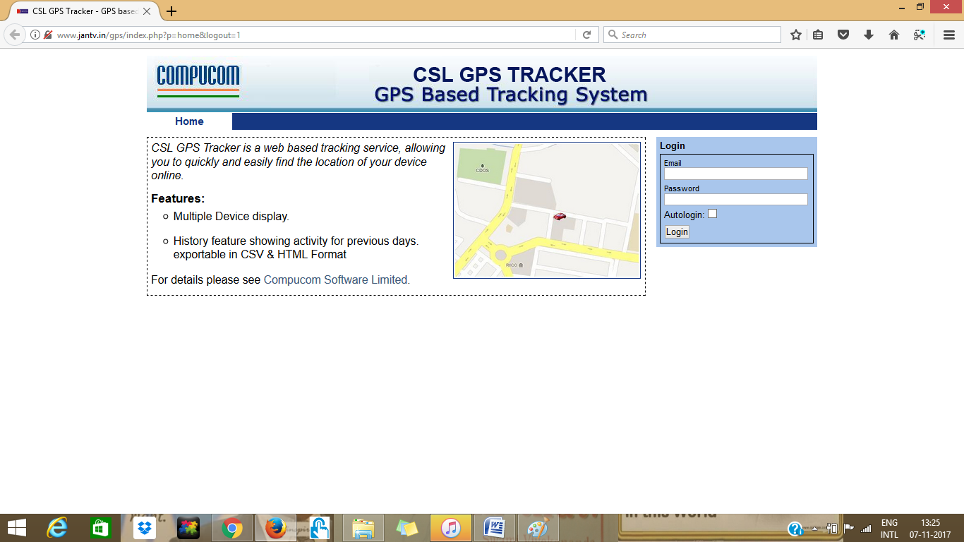

## Live Track Window for Admin

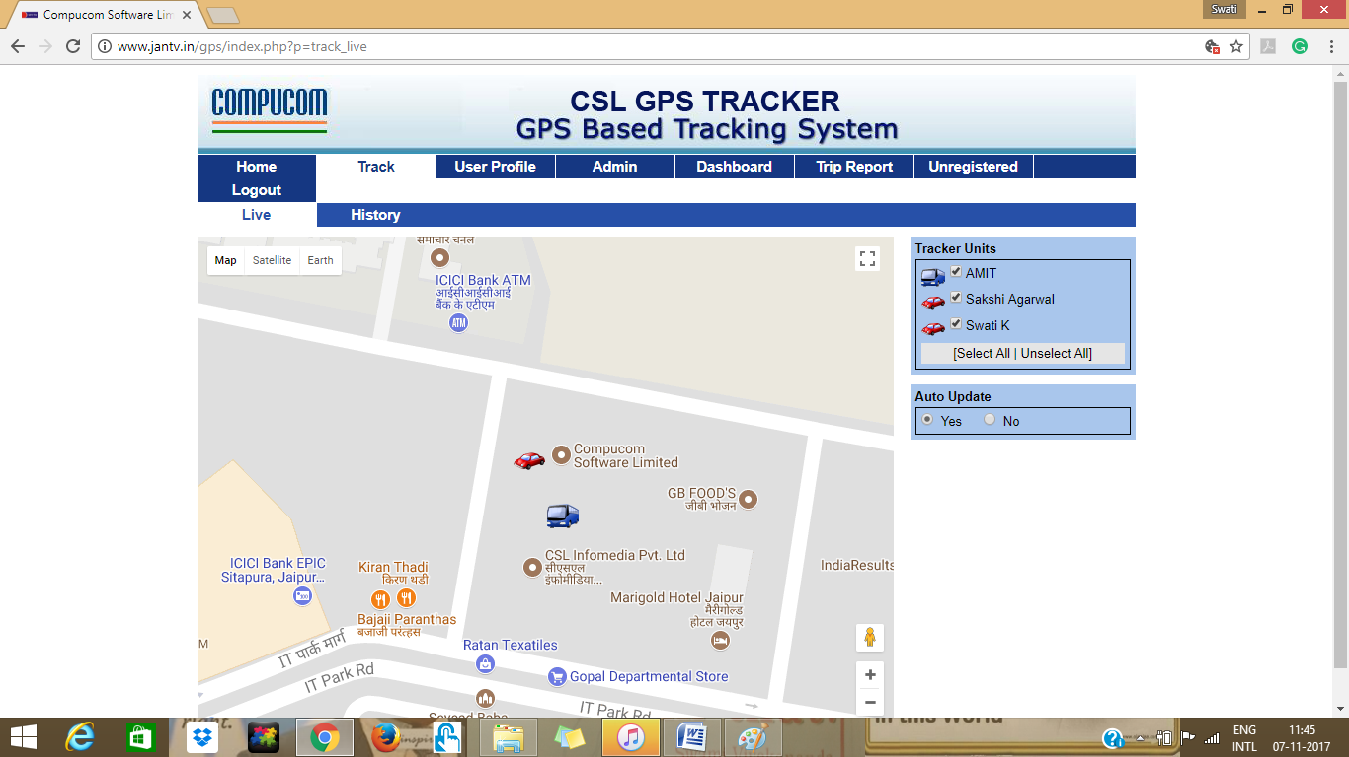

## LIVE TRACK WINDOW FOR CLIENT

It displays the live positioning of the device, who is being tracked.

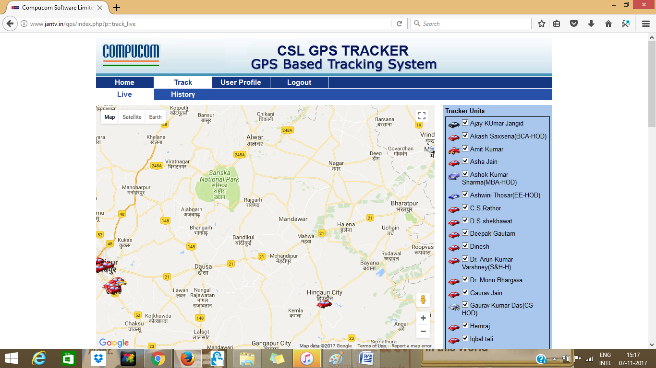

## TRACK HISTORY

Admin/Client can track location history of a person/device under History tab of the Track tab of the main menu.

User can choose to select the date for which he wants to track the device for.

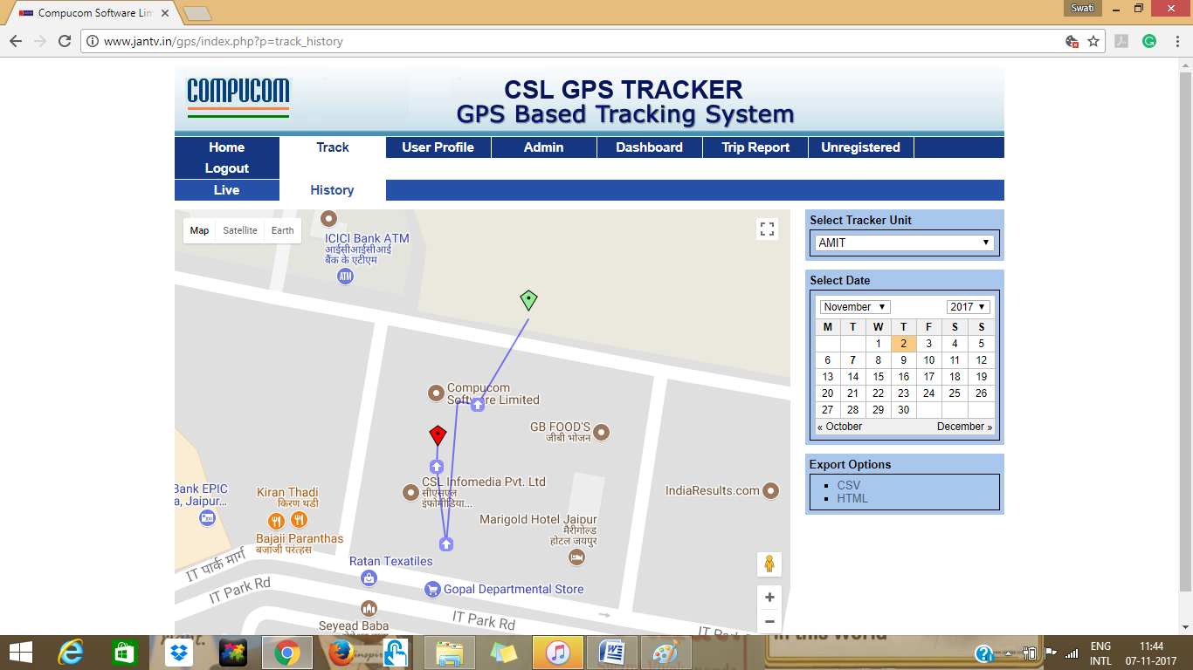

## MANAGE USER PROFILES

User can edit his profile and can manage devices to be tracked under **Edit** & **Tracker Config** tabs of the **User Profile** tab of main menu.

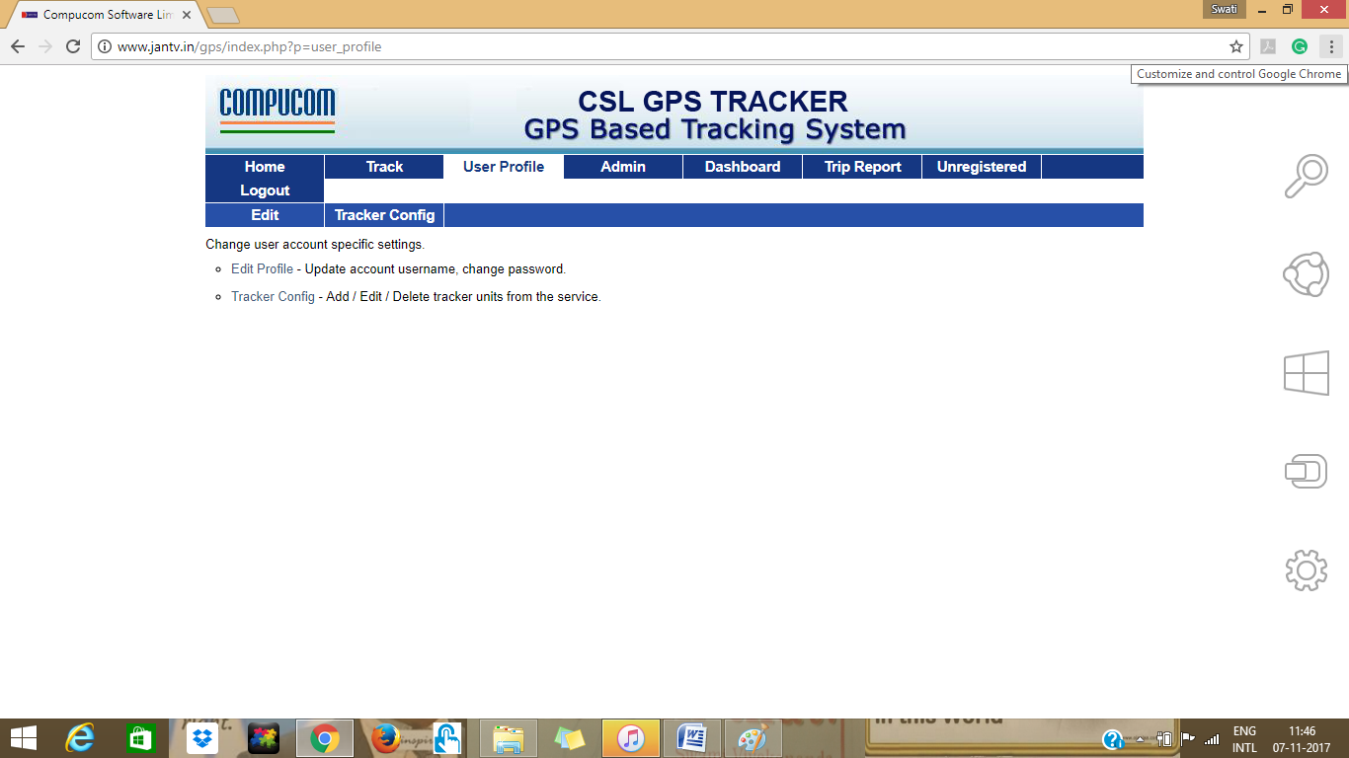

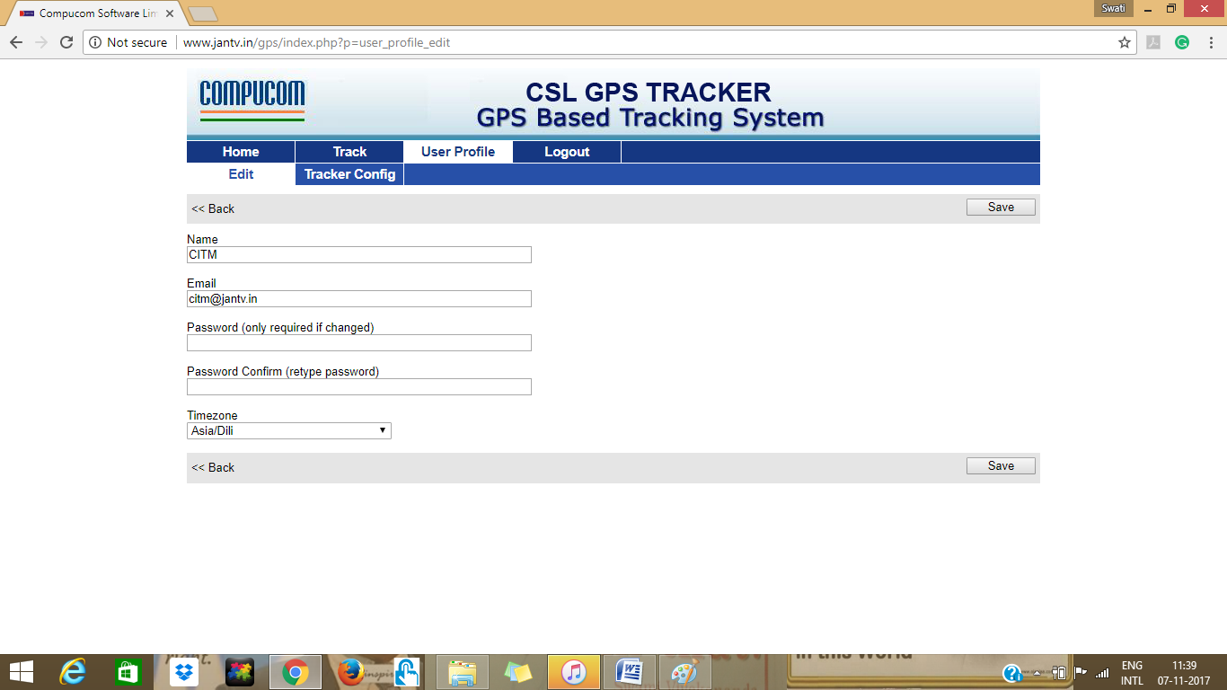

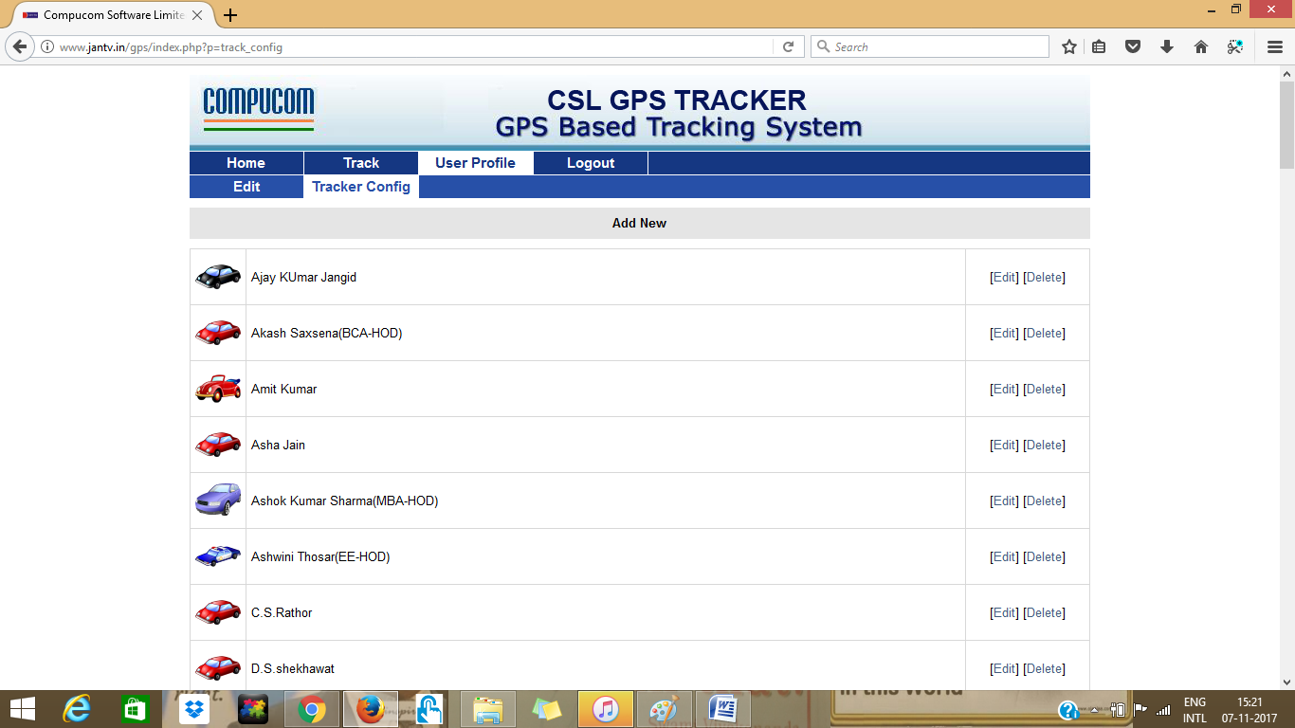

## Main Admin Page

Main admin can manage its clients/user details under **Admin** main menu tab. Main admin can login to a clients page using Login tab, can edit or check tracking details of the clients devices, can edit and delete client’s profile.

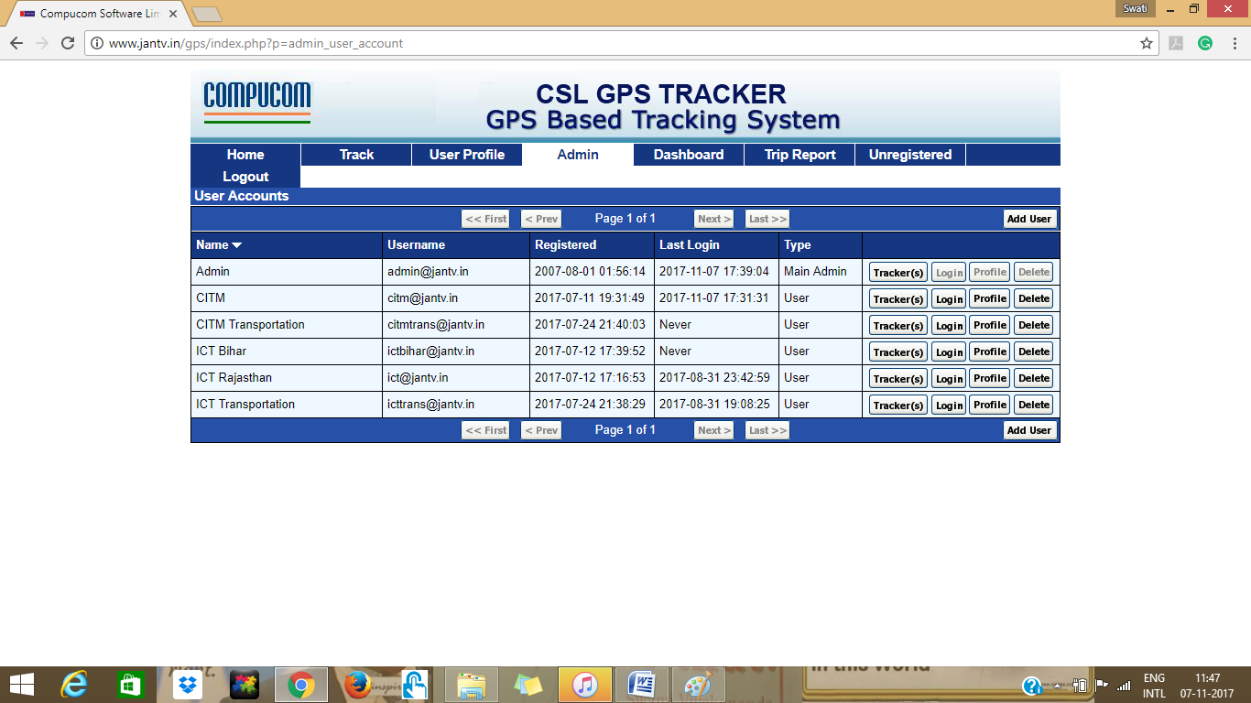

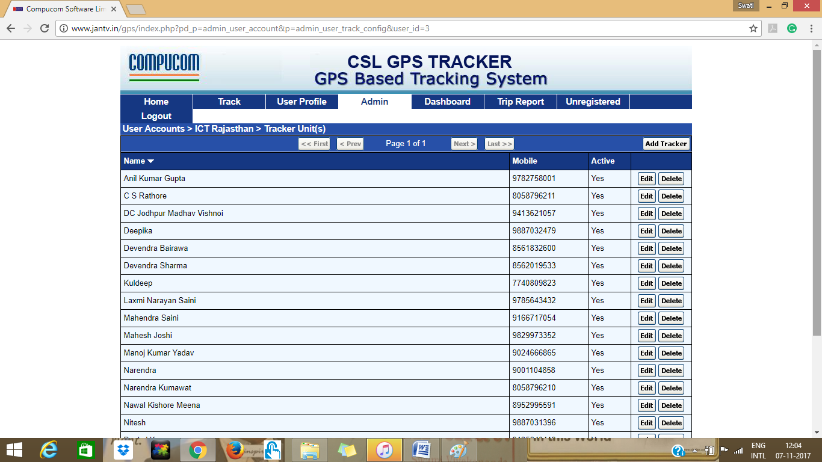

## Admin Dashboard

It’s a place where admin can check the last track status of a device and can send notifications to the devices which are inactive since long.

User can go back to the main menu with **Back** button given on the top right corner of the window.

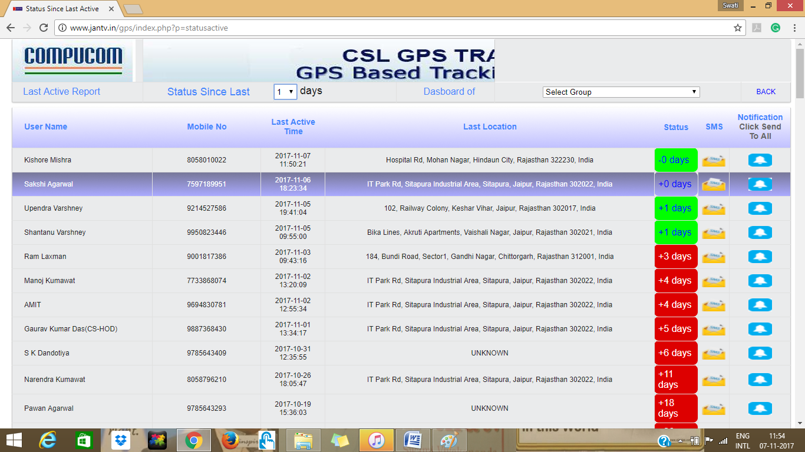

## TRIP REPORT

User can check the trip details of a device between a duration. One has to select the device owner name and the From and To date from the given drop-down menus.

User can go back to the main menu with **Back** button given on the top right corner of the window.

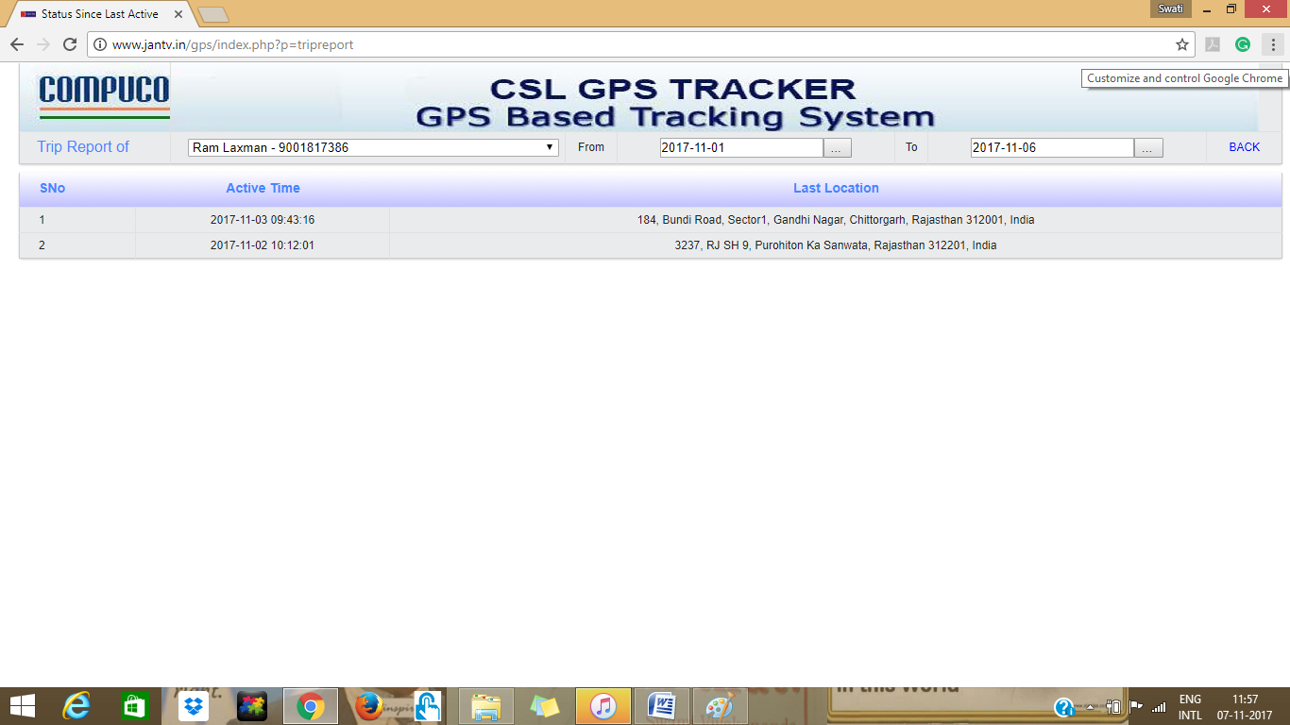

## UNREGISTERED USER

This window displays the unregistered users, who has downloaded the Compucom Gps Tracker app but are not yet registered.

User can go back to the main menu with **Back** button given on the top right corner of the window.

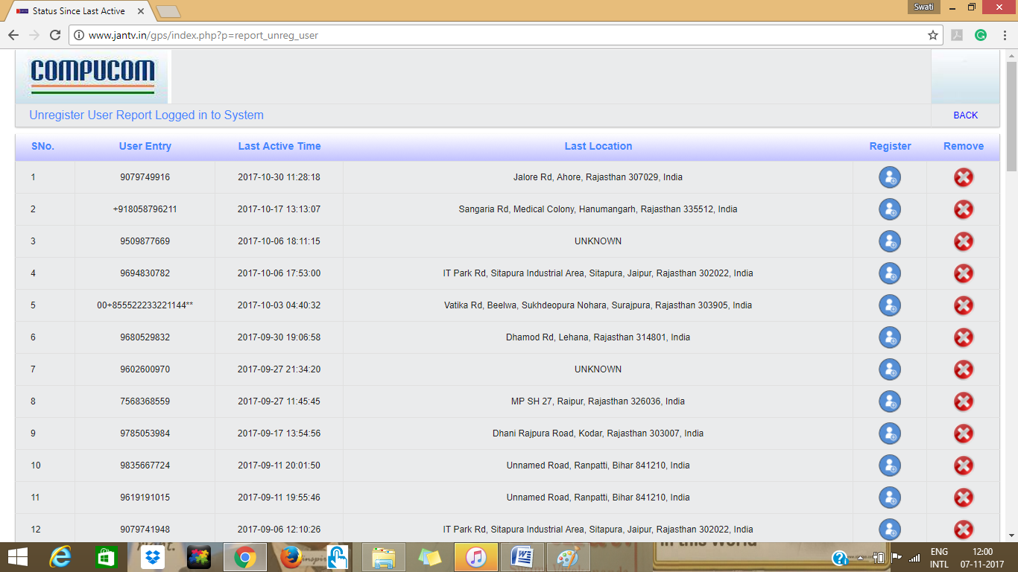

How to begin using Compucom GPS Tracker app ?

1. Download Compucom GPS Tracker app from Play Store
2. Open application on your Android device.
3. You will be getting the screen given in figure 1
4. Add your phone number in the given text box to register yourself.
5. Lastly, press the button given below saying “Tracking is Off”. It will open a window to direct you to turn your GPS or Location Services on.

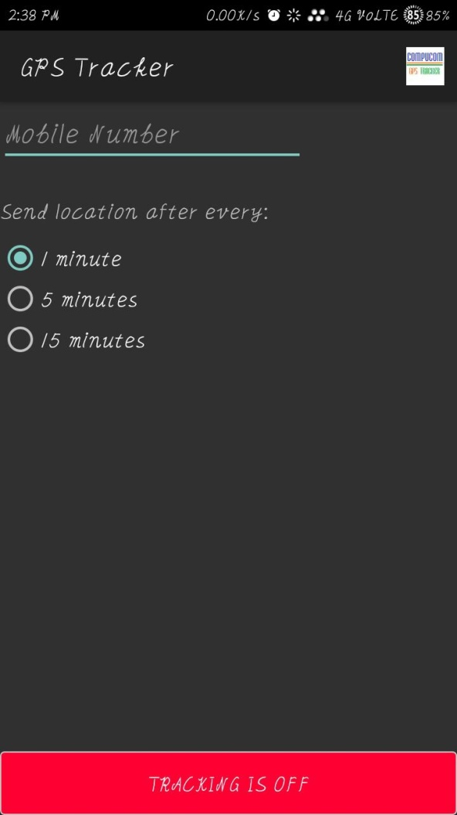 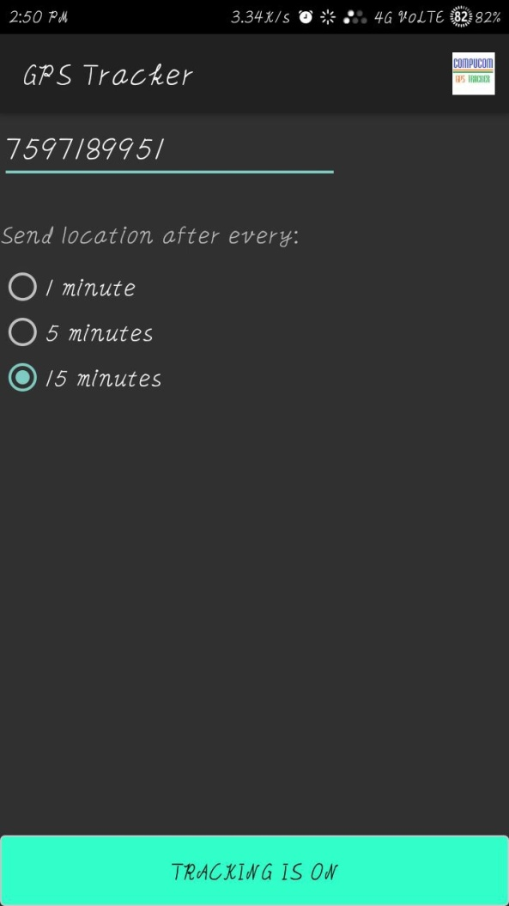

Figure 1: First Screen of Compucom GPS Tracker app Figure 2: Screen once your phone’s GPS Tracking .